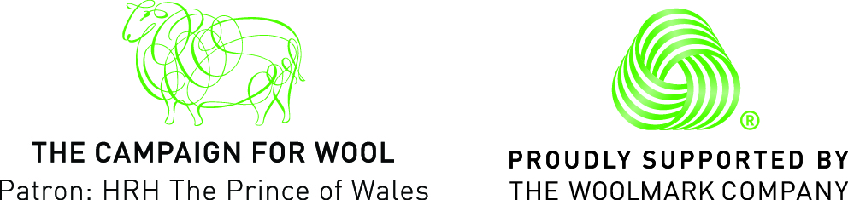

PRESS RELEASE
AUGUST 2015

CAMPAIGN FOR WOOL KICKS OFF WOOL WEEK 2015 WITH ‘SHEEP ON THE ROW’

August 2015 – This October The Campaign for Wool will mark the beginning of Wool Week 2015 by partnering with some of the world’s most prestigious tailors, menswear brands and cloth producers. Monday 5th October 2015 will see two sheep breeds grazing the length of Savile Row alongside models in a presentation to promote wool as the cloth of choice for menswear.

Savile Row – Sheep on the Row

One of the largest public events for Wool Week 2015 will take place on Savile Row - the centre of men’s luxury tailoring in London - on Monday 5th October 2015. As sheep graze, visitors will be welcomed to the open Row and tailoring houses event to learn how wool is used by the great British tailoring industry.

According to Mintel, released in June, the men’s clothing market has seen sales rise by 22% in the last five years to reach £13.5 billion in 2014, growing at a faster rate than womenswear, driven by a growing interest in men’s fashion and more retailers expanding into menswear. This year sales of menswear are set to reach £14.1 billion with 27% of male shoppers showing a preference for purchasing British clothes, shoes and accessories. The market has been bolstered by men’s interest in their appearance and their tendency to wear branded clothes more than women.

The iconic street will be transformed into a green pasture, covered in turf and closed to traffic while Bowmont Merino and Exmoor sheep graze along the Row. Barns will be at either end of the Row focusing on the landscapes of the main wool growing countries, Australia, New Zealand, South Africa and UK. Murdock London, the men’s groomers have partnered with Campaign for Wool to create a ‘Shearing Shed’ offering a menu of sheep-inspired grooming treatments, and GQ will partner to capture visitors to the Row in a ‘wool street style’ reportage of the best dressed men in London.

A ‘live’ model presentation that brings together leading wool mills, Savile Row, West End and London City bespoke tailors will showcase over 25 bespoke menswear outfits and demonstrate the versatility that can be found in wool. Each tailoring house will be partnered with a wool fabric mill and create contemporary bespoke menswear key pieces for AW15. The garments will be accessorized by the gentlemen’s houses of Mayfair and St. James’s, and supported by Globetrotter who will be supporting the ‘Traveller’ theme.

Members of the public will have access to the intricate processes involved in transforming wool from the fleece through to fabric; thus immersing themselves in the values of The Campaign for Wool. Savile Row – Sheep On The Row will be open to the public from 10:00 – 18:00 Monday 5th October.

About Wool Week

From 5th – 11th October, Wool Week will see over 100 retailers and many leading fashion, interior and craft brands from across the UK unite to highlight the innovative ways in which wool is used. Over the course of seven wool-filled days, the public will have the opportunity to participate in an exciting line-up of activities taking place across the country.

For more information about The Campaign for Wool please visit: www.campaignforwool.org

@Campaignforwool #ChooseWool

For questions regarding The Campaign for Wool and Wool Week, images and interview requests please contact:

Lucy Hirsch Emma Dearden
Mission Media Mission Media
Lucyh@thisismission.com Emmadearden@thisismission.com

Notes to Editors:

The Campaign for Wool was launched in 2010 to educate consumers about the benefits of wool, promote wool and wool-rich products to a national audience and help to support and grow the wool industry. Run by a coalition of industry groups convened by His Royal Highness The Prince of Wales, the campaign works to engage consumers through exciting fashion, interiors, artisan and design lead activities centring around Wool Week each year.

